Number 1
Multiply 3.4 × 10⁻⁵ by 7.1 × 10⁸ and leave the answer in the standard form.

- 2.414 × 10²
- 2.414 × 10
3
- 2.414 × 10
4
- 2.414 × 10
5

Number 2
Given that P = {p : 1 < p < 20}, where p is an integer and R = {r : 0 ≤ r ≤ 25, where r is a multiple of 4}. Find P ∩ R.

- {4, 8, 10, 16}
- {4, 8, 12, 16}
- {4, 8, 12, 16, 20}
- {4, 8, 12, 16, 20, 24}

Number 3
The first term of an arithmetic progression is 2 and the last term is 29. If the common difference is 3 , how many terms are in the arithmetic progression?

- 8
- 9
- 10
- 11

Number 4

A boy 1.4 m tall, stood 10 m away from a tree of height 12 m. Calculate, correct to the nearest degree, the angle of elevation of the top of the tree from the boy’s eyes.

A. 70◦;B. 47◦;C. 19◦;D. 8◦

Number 5
Simplify: (2p − q)² − (p + q)².

- 3p(p − 2q)
- 2p(p − 3q)
- 3p(2p − q)
- 2p(3p − q)

Number 6

A ladder 6 m long leans against a vertical wall at an angle 53◦ to the horizontal. How high up the wall does the ladder reach?
A. 3.611 m;B. 4.521 m;C. 4.792 m;D. 3.962 m

Number 7
Find the sum for which $1, 250.00 will amount to $2, 031.25 at 12.5% per annum simple interest.

- 2 years
- 3 years
- 4 years
- 5 years

Number 8
If log^{2x−1} = 5, find the value of x.
3

- 8
- 16
- 64
- 122

Number 9
The population of a town increases by 3% every year. In the year 2000, the population was 3000. Find the population in the year 2003.

- 3278
- 3127
- 3556
- 3618

Number 10
A trader gave a change of N 540.00 instead of N 570.00 to a customer. Caculate the percentage error.

- 5 ⁵ %
19
- 5⁵ %
9
- 5 ⁷ %
19
- 5⁷ %
9

Number 11

The interior angle of a regular polygon is 168○. Find the number of sides of the polygon.

- 24
- 30
- 15
- 12

Number 12
If 3x − 2y = −5 and x + 2y = 9, find the value of .
x+y
x−y

- ⁵
3
- ³
5
- −3
5
- −5
3

Number 13
A variable W varies partly as M and partly inversely as P. Which of the following correctly represents the relation with k₁ and k₂ constants?

- W = ^{k}1M
k P
2
- W = (k₁ + k₂) ^{M}
P
- W = k₁M + ^{k}2
P
- W = (k₁ + k₂) M + P

Number 14
A cylindrical metallic barrel of height 2.5 m and radius 0.245 m is closed at one end. Find, correct to one decimal place, the total surface area of the barrel. [Take π = ²² ]
7

- 2.1 m²
- 3.5 m²
- 4.0 m²
- 9.4 m²

Number 15

Find the 17th term of the arithmetic progression, given that first three terms are 6, 1, 4.

A. 91;B. 86;C. 74;D. 79

Number 16
Consider the following statements: m = Edna is respectful, n = Edna is brilliant.

If m ⇒ n, which of the following is valid?
A. ¬n ⇒ ¬m.
B. ¬m ⇒ ¬n.
C. n ⇒ ¬m.
D. m ⇒ n.

Number 17
A number is added to both the numerator and the denominator of the fraction ¹ if the result is
8
¹ , find the number.
2

A. 3
B. 4
C. 5
D. 6

Number 18
Gifty, Justina, and Frank shared 60 oranges in the ratio 5: 3: 7 respectively. How many oranges did Justina receive?

A. 16
B. 12
C. 20

D. 28

Number 19
Find the quadratic equation whose roots are ² and - 1.
3

A. 3x² x 2 = 0
− −
B. 3x² + x + 2 = 0
C. 3x² + x − 2 = 0
D. 3x² + x − 1 = 0

Number 20
A piece of rod of length 44 m is cut to form a rectangular shape such that the ratio of the length to the breadth is 7 : 4. Find the breath.

A. 8 m
B. 14 m
C. 16 m
D. 24 m

Number 21

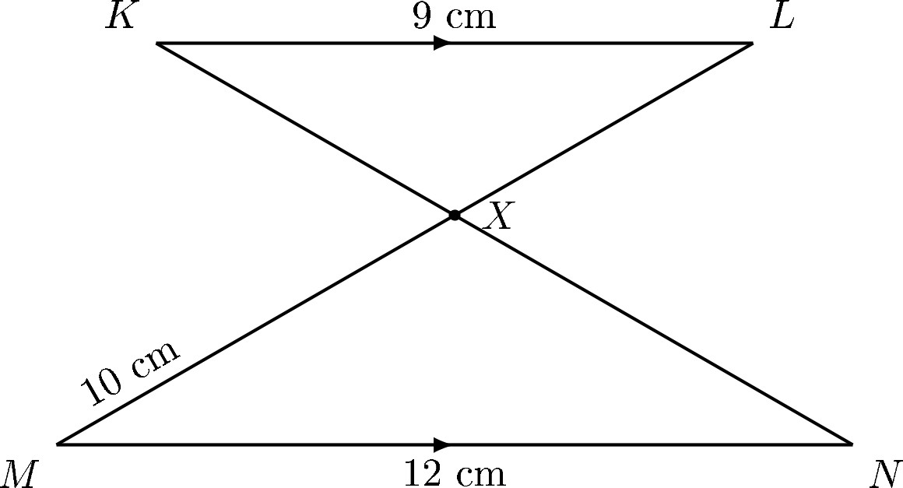

In the diagram, MN | | KL, ML and KN intersect at X.|MN | = 12 cm, |MX| = 10 cm and
|MN | = 9 cm. If the area of ΔMXN is 16 cm , calculate the area of Δ LXK.
2

A. 9 cm²
B. 8 cm²
C. 10 cm²
D. 12 cm²

Number 22
A ladder 15 m long leans against a vertical pole, making an angle of 72○ with the horizontal. Calculate, correct to one decimal place, the distance between the foot of the ladder and the pole.

A. 15.8 m
B. 14.3 m

C. 4.9 m
D. 4.6 m

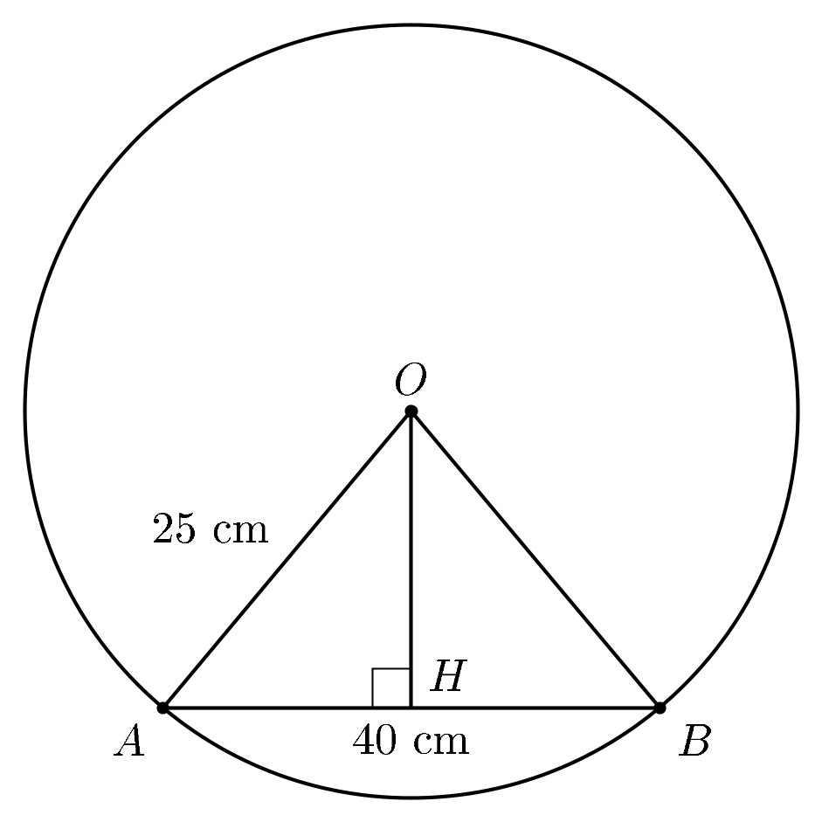
Number 23

In the diagram, O is the centre of the circle. If |OA| = 25 cm and |AB| = 40 cm, find |OH|.

A. 15 cm
B. 20 cm
C. 25 cm
D. 30 cm

Number 24
A car valued at $600, 000.00 depreciates by 10% each year. What will be the value of the car at the end of two years?

A. $120, 000.00
B. $480, 000.00
C. $486, 000.00
D. $540, 000.00

Number 25
Given that P is 25 m on a bearing of 330○ from Q, how far south of P is Q?

A. 25.2 m
B. 21.7 m
C. 19.8 m
D. 18.5 m

Number 26

The length and breadth of a cuboid are 15 cm and 8 cm respectively. If the volume of the cuboid is 1560 cm³, calculate the total surface area.

A. 976 cm²
B. 838 cm²
C. 792 cm²
D. 746 cm²

Number 27
The number 1621 was subtracted from 6244 in base x. If the result was 4323, find x.

A. 7
B. 8
C. 9
D. 10

Number 28
Factorize completely: 27x² − 48y².

A. 3(3x + 4y)(3x 4y)
—
B. 3(3x + 4y)(3x + 4y)
C. 3(9x − 16y)(9x + 16y)
D. 3(9x − 16y)(9x − 16y)

Number 29
For what values of x is ^{x−3} + ^{x+1} ≥ 2?
4
8

A. x ≥ 5
B. x ≥ 6
C. x ≥ 7
D. x ≥ 8

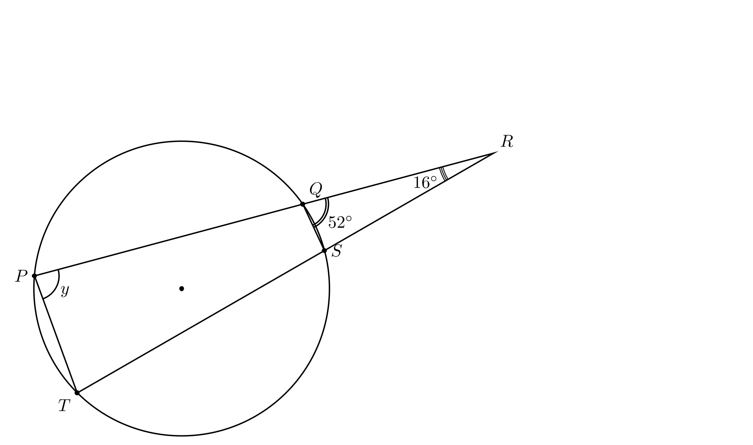
Number 30

In the diagram, ∠SQR = 52○ and ∠PRT = 16○. Find the value of the angle y.

A. 64○
B. 68○
C. 112○
D. 128○

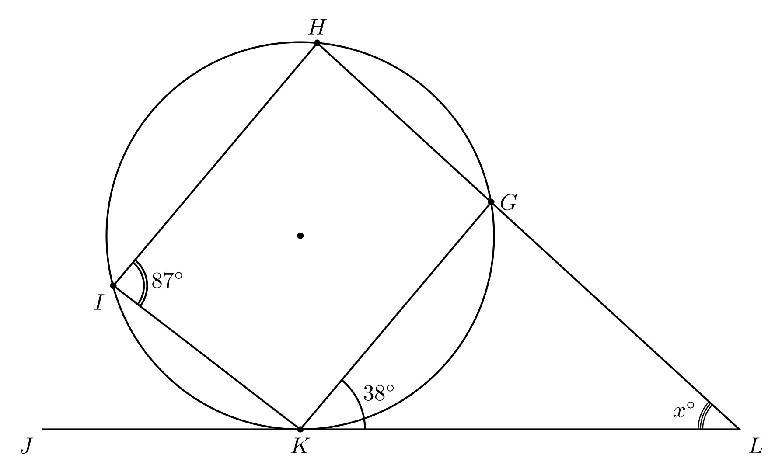
Number 31

In the diagram above, JKL is a tangent to the circle at K, ∠LKG = 38○, ∠KIB = 87○. Find
∠KLG.

A. 93○
B. 55○
C. 42○
D. 23○

Number 32
A cone and a cylinder are of equal volume. The base radius of the cone is twice the radius of the cylinder. What is the ratio of the height of the cylinder to that of the cone?

A. 5:4
B. 4:3
C. 3:2
D. 3:4

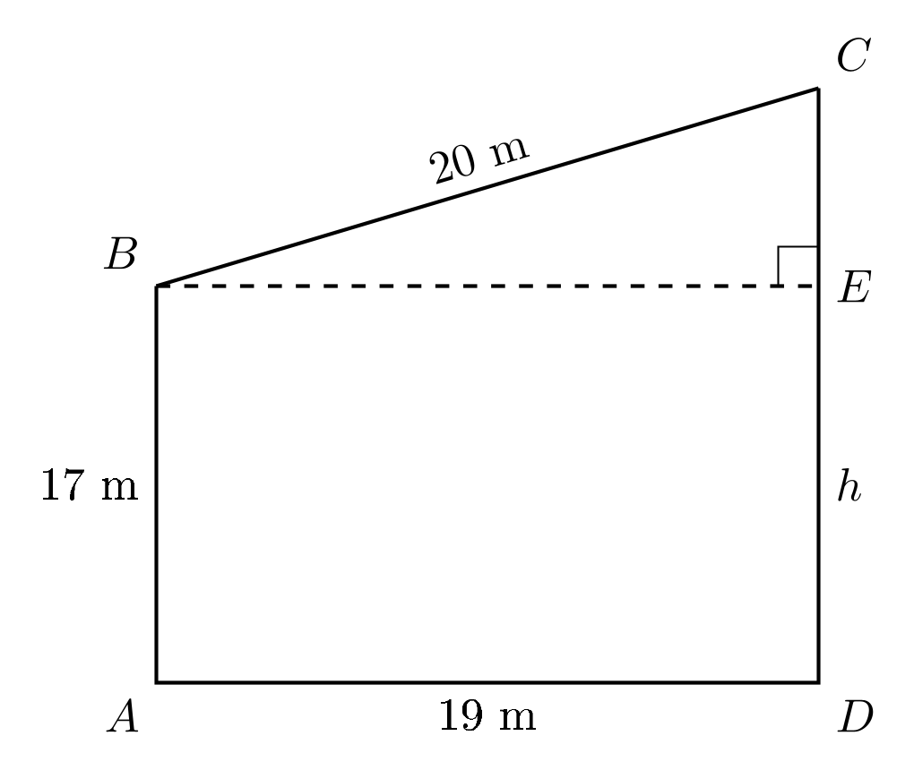
Number 33

Find, correct to the nearest whole number, the value of h in the diagram above.

A. 15 m
B. 22 m
C. 23 m
D. 18 m

Number 34
The gradient of the line joining the points P (2, −8) and Q(1, y) is −4. Find the value of y.

A. 2
B. 4
C. -4
D. -3

Number 35

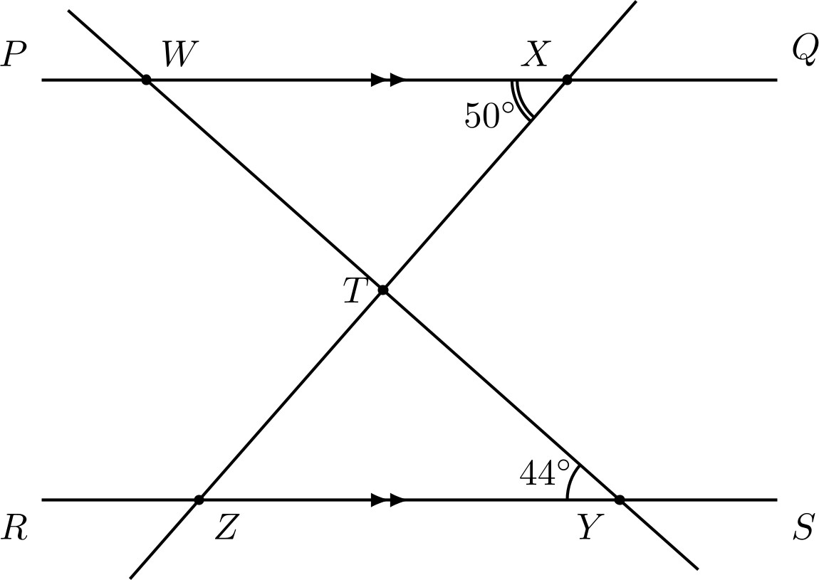
In the diagram above, PQ RS, ∠WYZ = 44○ and ∠WXY = 50○. Find ∠WTX.
A. 65○
B. 68○
C. 86○
D. 90○

Number 36
The perimeter of a rectangular garden is 90 m. If the width is 7 m less than the length, find the length of the garden.

A. 19 m

B. 23 m
C. 24 m
D. 26 m

Number 37
Four of the angles of a hexagon sum up to 420○. If the remaining angles are equal, find the value of each of the angles.

A. 60○
B. 100○
C. 120○
D. 150○

Number 38

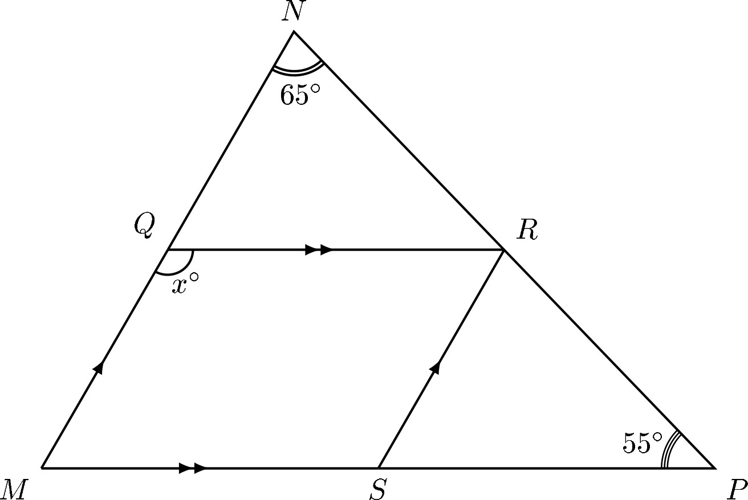
Find the value of x in the diagram above.
A. 120○
B. 100○
C. 60○
D. 150○

Number 39
The following are the masses, in kg, of members in a club: 59, 44, 53, 49, 57, 40, 48, and 50. Calculate the mean mass.

A. 44 kg

B. 50 kg
C. 40 kg
D. 53 kg

Number 40
The following are the masses, in kg, of members in a club: 59, 44, 53, 49, 57, 40, 48, and 50. Calculate the variance of the distribution.

A. 35
B. 36
C. 40
D. 50

Number 41
Two opposite sides of a rectangle are (5x +3) m and (2x +9) m. If an adjacent side is (6x 7) m, find, in m², the area of the rectangle.
—

A. 45
B. 65
C. 125
D. 165

Number 42
A die is tossed once. Find the probability of getting a prime number.

A. ¹
2
B. ¹
6
C. ¹
3
D. ²
3

Number 43
The area of a sector of a circle with radius 7 cm is 51.3 cm². Calculate, correct to the nearest whole number, the angle of the sector. [Take π = ²² ]
7

A. 60○
B. 120○
C. 150○
D. 150○

Number 44
A cliff on the bank of a river 87 m high. A boat on the river is 22 m away from the cliff. Calculate, correct to the nearest degree, the angle of depression of the boat from the top of the cliff.

A. 76○

B. 64○
C. 36○
D. 24○

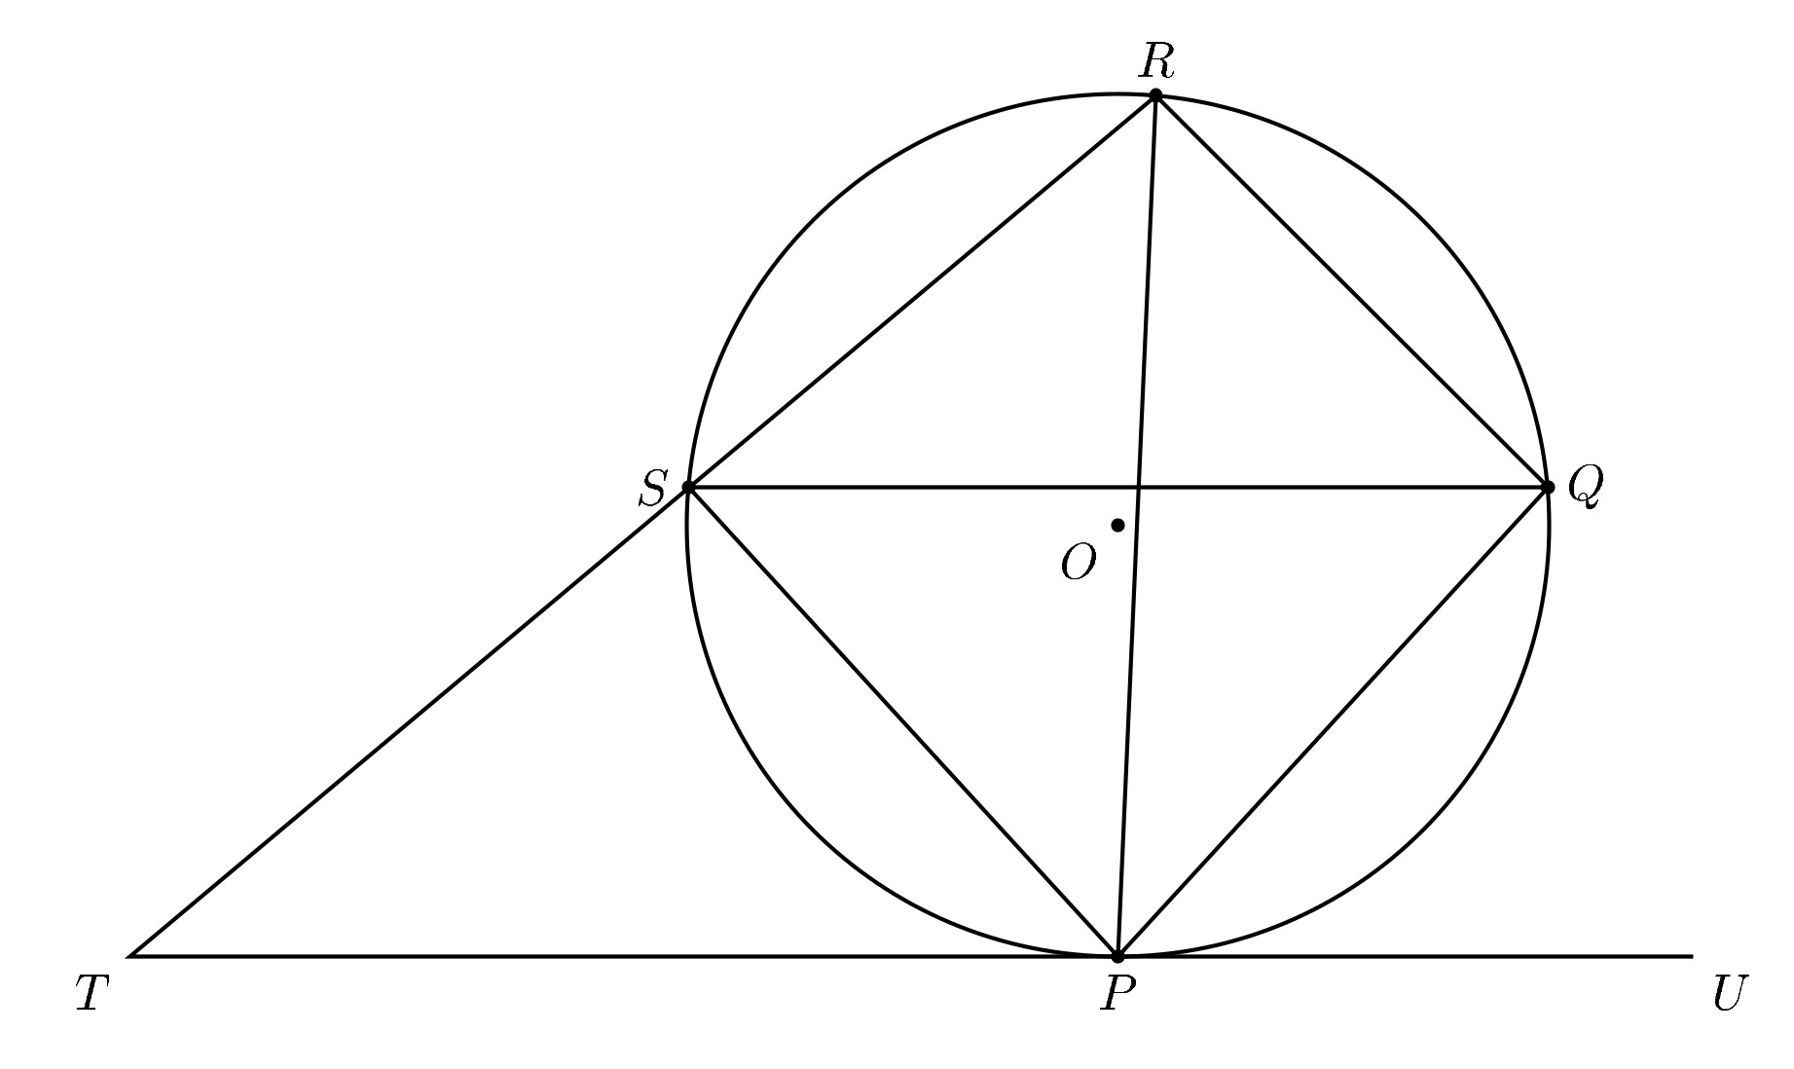
Number 45

In the diagram, TU is a tangent to the circle at P. If ∠PTS = 44○, ∠SQP = 35○, find ∠PST.
A. 101○
B. 125○
C. 130○

D. 135○

Number 46
The probability that Amaka will pass an examination is ³ and that Bala will pass is ⁴ . Find the

7 9
probability that both will pass the examination.

2 21
A.
B.
4
21
5
C.
21
9
D.
21

Number 47
Which of the following points lies on the line 3x − 8y = 11?

A. (1, 1)
B. (1, −1)
C. (−1, 1)
D. (−1, −1)

Number 48
Find the range of the following set of numbers: 28, 29, 39, 38, 33, 37, 26, 20, 15, and 25.

A. 22
B. 24

C. 25
D. 27

Number 49
The fourth and eighth terms of an arithmetic progression are 16 and 40 respectively. Find the common difference.

A. -6
B. 6
C. -2
D. 2

Number 50

Given that sin(5x 28)◦ = cos(3x 50)′′, 0◦ x 90◦, find the value of x. Possible answers:

A. 39;B. 32;C. 21;D. 14

Answer
- C
- B
- C
- B
- A
- C
- D
- C
- A
- A
- B
- C
- C
- C
- B
- A
- D
- B
- C
- A
- A
- D
- A
- C
- B
- B
- A
- A
- C
- A
- B
- B
- C
- C
- C
- D
- D
- A
- B
- A
- B
- A
- B
- A
- A
- B
- B
- B
- B
- C

